Experiment 1: Operations on Discrete Time Signal

1. Signal Folding

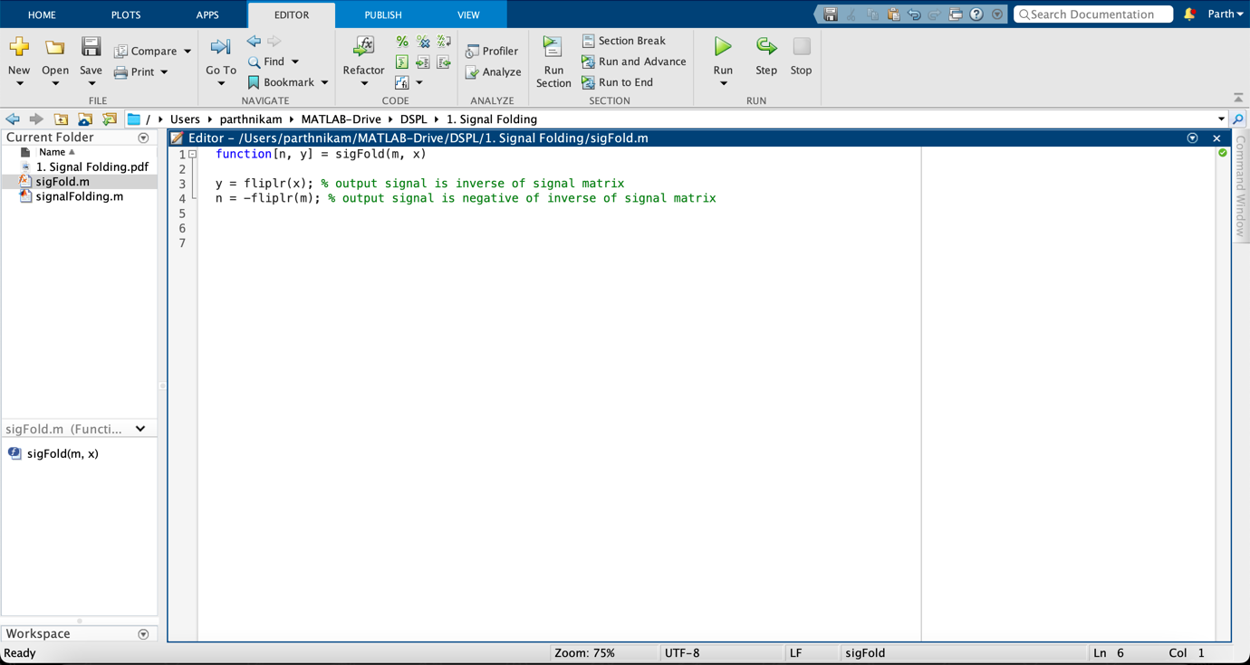

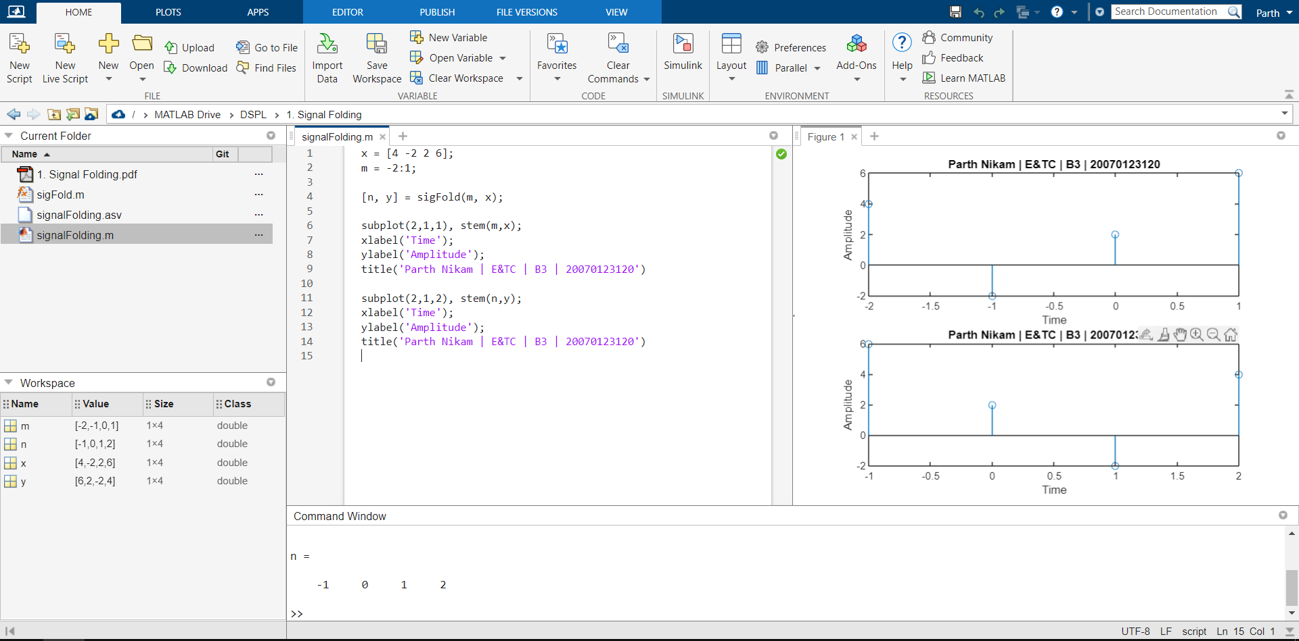

1. Signal Shifting

1. Signal Addition

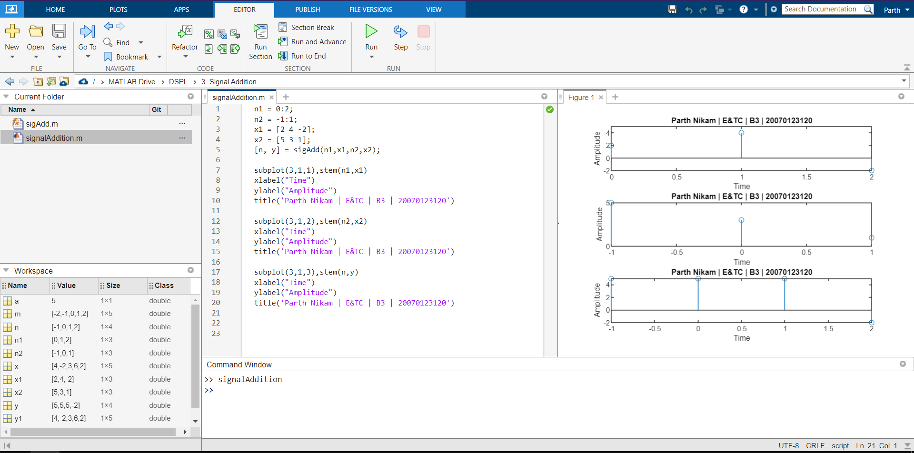

1. Signal Multiplication

